4 Instructions for Competitors

Rules
The event will be run under the British Rowing Rules of Racing April 2017 and Row Safe.
Any contravention of the rules may result in disqualification.
The Race Committee reserve the right to amend the order of the race programme.
Equipment
Athletes and coaches are responsible for ensuring their equipment is safe and suitable for use. Boats and individuals not complying with Row Safe will be subject to a BR Incident Report. Compliance will be monitored by the Control Commission umpires on a spot check basis.

All crews must wear their official club kit. Loose clothing and hoodies will be discouraged.
Welfare policy
The Organising Committee believe that the welfare and wellbeing of all children is paramount. All children, regardless of age, gender, ethnicity, religion or ability, have equal rights to safety and protection. All suspicions, concerns and allegations of harm will be taken seriously and responded to swiftly and appropriately.
A Welfare Officer/coordinator for the competition will be appointed annually and will act as the point of contact for any concerns or allegations. Their contact number (07974 790644) will be posted in the boating area throughout the duration of the competition.

Parking
Parking is limited so please travel with as many people as possible in one car and obey the instructions of the parking marshals. There is an overspill car park at Bishops High School five minutes walk from the Regatta Ground. A map of how to get to and from this School is attached at Figure 2. The car park will be open from 0700-1900.Boat trailers should be parked only in the designated hardstanding area, but all boat assembly except eights must take place in the main regatta ground. Assembly and boating of eights will take place on the Sandy Lane slipway. Two trailers are available for the temporary storage of boats in the main regatta ground.
Changing Facilities
Changing facilities, toilets and showers are provided in Chester Sailing and Canoeing Club at the upstream end of the Regatta ground and separate toilet facilities are located adjacent to the trailer park, as shown in the attached schematic.

Registration
British Rowing licences are required for all competitors with the exception of J13
and younger.
Coxes are responsible for meeting the minimum weights for their class and must be weighed and certificated.
Numbers must be worn clearly visible on the back of the bowman and on the sides of boats and in the Empacher slots. Crews rowing in more than one event must wear only the number applicable to the event they are racing in.

Navigation Lanes
All competitors must familiarise themselves with the circulation pattern (see attached map) for themselves and for other traffic since the river remains open throughout the Regatta. The short races will start at the private stage just upstream of the Red House restaurant. The long races will start at Heronbridge as indicated on the course map. All races will finish at the Sandy Lane slipway. Marshalling for the long course will take place upstream of the Heronbridge bend. Crews proceeding to the start should keep to the enclosure side of the buoys and all racing crews should keep to the Meadows side of the buoys. All clubs must ensure that their equipment is safe and satisfies the British Rowing Rules.

Embarkation
Crews should pair up wherever possible with their opposition near the outgoing stage prior to getting afloat. Crews who have a bye in the first round of their event should note that their opposition will probably already be on the water from their previous race and will not be expecting to disembark for pairing up.
Control Commission umpires will carry out a boat check to ensure that heel restraints, bow balls, buoyancy compartments and general fixings meet British Rowing Row Safe requirements. Stage marshals will also ensure that all coxes are wearing suitably fitted life jackets and carrying weights where appropriate.

Boating
To improve boating facilities all embarkation and disembarkation will be from the beaches at the sailing club so wellies, crocs or sandals will be required. A one way flow system will be in operation as shown in Figure 3.

Going to the Start
On the way to the start for the short races crews must pair up with their opposition and paddle upstream. Crews should not cross the line of buoys or stop or loiter on the way to the start because the navigation lane will be used by other river traffic going upstream. All crews should stop opposite the start, indicate their identity and crew number and request instructions from the Upstream Start Marshal before proceeding upstream. When crews are paired up and instructed to do so by the boat marshal they should turn downstream around the large buoy and proceed alongside their opposition towards the start. On approaching the start with their opposition they should obey the instructions of the Downstream Start Marshall to ensure they are positioned correctly for a timely and unobstructed start.
Crews for the long races should ensure that they are in position pointing upstream of the Heronbridge corner no less than 20 minutes prior to the start and should turn downstream to proceed to the start only when ordered to do so by the marshals.
Competitors wishing to practice may do so only upstream from the race starts.
Start marshals will control crews assembling below the short start and ensure that they are paired up and presented to the start.

The Short Start
Crews must be on the short start 2 minutes before the race time stated in the programme or risk disqualification.
The first named crew on the programme will race on the Sandy Lane station.

The Finish
A bell will sound at the finish of each race and the result will be announced over the PA system.
At the finish crews must not obstruct the finish line and should promptly continue downstream and circle in a clockwise direction around the finish marshal’s boat situated in the middle of the river before returning to the incoming stage.

Medical Cover
First aid cover will be provided by the St John Ambulance Brigade who will be based in the Sailing Club.
The nearest hospital is the Countess of Chester, Liverpool Road, Chester. Tel 01244 365000.

Safety
Two safety launches will be provided by Chester Boats under contract, one located in the vicinity of the start designated ‘Safety Launch Start’ and one, designated ‘Safety Launch Finish’, in the vicinity of the finish line.

Contacts

Regatta Chairman Stuart Gillies (07817 549087)
Safety Adviser John Browne (07785 550991)
Welfare Officer Lisa Jones (07974 790644)

Figure 1
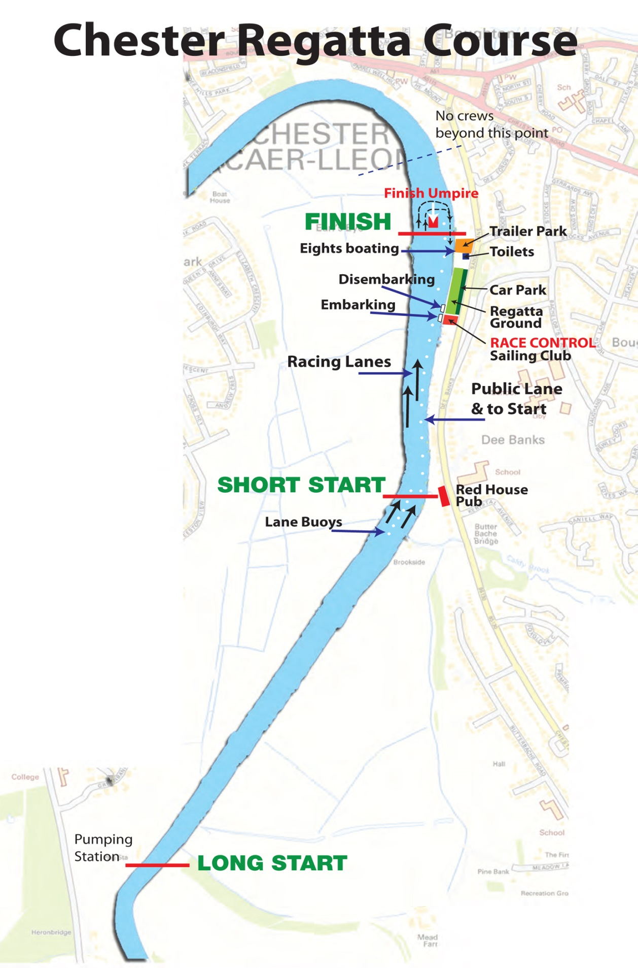

Figure 2
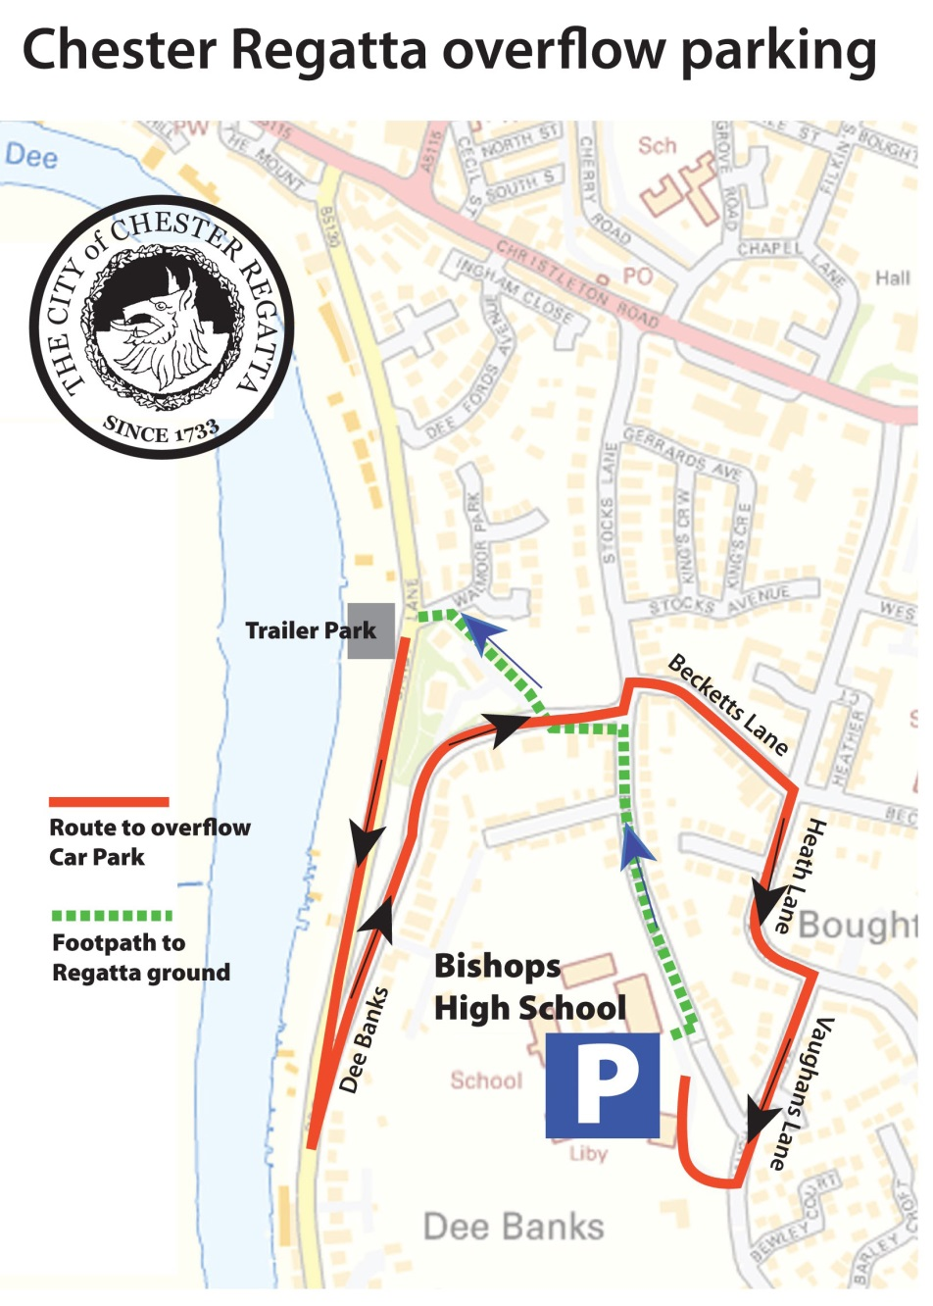

Figure 3
