CHESTER REGATTA SUPPORT TEAM JOB DESCRIPTIONS
Marshalling Overview

All crews making their way upstream to the start should stop opposite the sailing club where the start controller is located.
The start controller will tell them the crew number and club they are racing against and which side of the course they are racing on.
Crews should then proceed to the start and follow the instructions of the Launch Marshal and find their opposition
Paired crews turn downstream at red buoy when ordered to by Launch Marshal (LM2)
Paired crews proceed downstream to White Buoy
Paired crews called forward by the start umpire

Start Umpire starts crews racing

Job Descriptions
- Volunteer Registrar
Checks in all volunteers against rota before shift commencement.
Issues role description laminated cards
Resolves any role description issues
Defines location of role
Issues equipment: radios, loud hailers etc
Checks out volunteers at end of shift and provides thankyou gift.
- Car Parking Warden
Controls access to Sandy Lane carpark (boat trailers and officials only)
Directs cars and minibuses to verge parking
Issues map and directions to overflow parking at Bishops High School
Supervises car park assistants (x2)
Equipment: Hiviz jacket, maps for route to Bishops High
- Boating Marshal – Embarkation,
Assists crews going afloat
Controls sequence of crews going afloat
Equipment: hiviz jacket, wellies
- Boating Marshal - Disembarkation
Assists crews coming ashore
Controls sequence of crews coming ashore
Equipment: hiviz jacket, wellies
- Boating Marshal – Circulation
Controls flow of crews after Control Commission examination through Sailing Club one-way system as shown on the boating plan/ground plan
Equipment: hiviz jacket, circulation plan
- Boating Marshall Sandy Lane Slipway
Assists 8s going afloat and coming ashore at slipway
Equipment: hiviz jacket, wellies
- Satellite Boating Marshal
Manages boating at boathouses remote from Regatta ground (Royals, Kings, Grosvenor,)
Ensures Empacher numbers collected from Regatta ground
Ensures coxes weighed at Regatta ground
Ensures crews have checked their boats and conducts random spot boat safety checks prior to embarkation. Keeps track of who has boated.
Locates any missing crews
Monitors regatta progress on line or by radio
Ensures timely embarkation of crews
Responds to questions from Start Controller about location of crews usingradio channel 2
Equipment : laptop, race schedule, radio, highviz jacket

- Launch (Start) Marshals (LM1 and LM2)
LM1 drives launch.
LM2 updates copy of Race Schedule to show which crews have won and which later races they go forward to by listening to the results of races on Channel 1. If results are missed LM2 asks Race Control to repeat result.
As crews arrive LM2 records their presence on the Race Schedule and advises them of the identity and location of their opposition and the side of the river for their race.
If a crew has not arrived when expected LM2 should ask the Start Controller on Channel 2 whether the crew has passed him and if not then Control Commission to ask whether they have boated. If not LM2 should contact the Start Umpire who will decide what is to be done.
LM2 assists crews to pair up
LM2 instructs paired crews to turn at red buoy and proceed downstream to start
Equipment: lifejackets, 2 Radios, protected clipboard, loud hailer, Race Schedule
- Start Controller
Start Controller is stationed outside the sailing club on the riverbank and works with the Assistant Start Controller who is an umpire. Between them they upate the Race Schedule to show which crews have won and which later races they go forward to by listening to the results of races on Channel 1. (If any results are missed the Start Controller should ask Race Control to repeat the result.)
As crews head upstream to the start past their position, the Start Controller should stop them and advise them of the identity and location of their opposition and the side of the river for their race. The Start Controller should record their passing on the Race Schedule.
The Start Controller should also answer queries from LM2 on Channel 2 regarding late or missing crews.
Equipment: hiviz jacket, loud hailer, two radios, protected clipboard, Race Schedule
- Whatsapp Operator Start
Is stationed at the start and uses the tablet provided to record the races as they start, recording the race number, crew numbers and which side they are racing on (Enclosure or Meadows side)

Equipment: tablet, race schedule

- Whatsapp Operator FinishWhatsapp Operator Finish
Is stationed at the finish and uses the tablet provided to record the races as they finish, recording the race number, winning crew number and distance by which they beat the other crew.

Equipment: tablet, race schedule
- Finish Recorder
Assists the finish umpire by record the number of the winning crew and the distance by which it won. The umpire will provide the documentation. May also be asked by the umpires to radio results to race control. The umpire will explain how this is done and provide the radio.
Equipment: clipboard
- Launch Controller
Allocates launches and drivers to umpire transport, refreshment supplies and delivery of updated regatta schedules.
Equipment: hiviz jacket, radio, mobile phone
- Launch Drivers (Umpire Service)
From ferry landing stage transport umpires, refreshment supplies and delivery of updated regatta schedules to and from start and finish pontoon.
Equipment: hiviz jacket, radio (with umpire).
- Launch Drivers (Mobile Umpire)
Transport umpires to patrol Meadows side of course as requested.
Equipment: hiviz jacket, radio (with umpire)
- Commentator
Delivers commentary over public address system
- Welfare Officer
Deals with any welfare issues

- Facilities Manager
Connects and disconnects power and water supplies
Removes and replaces Sailing Club fence
Assists with site clearance at end of regatta
Assists with removal and restoration of trophies to bank
Equipment: mobile phone
- Safety Officer
Procures and controls safety launches and St John ambulance first aid team
Develops event and safety plan and marshal role descriptions
Recruits race marshals and draws up duty roster
Equipment: hiviz jacket, radio, mobile phone

Figure 1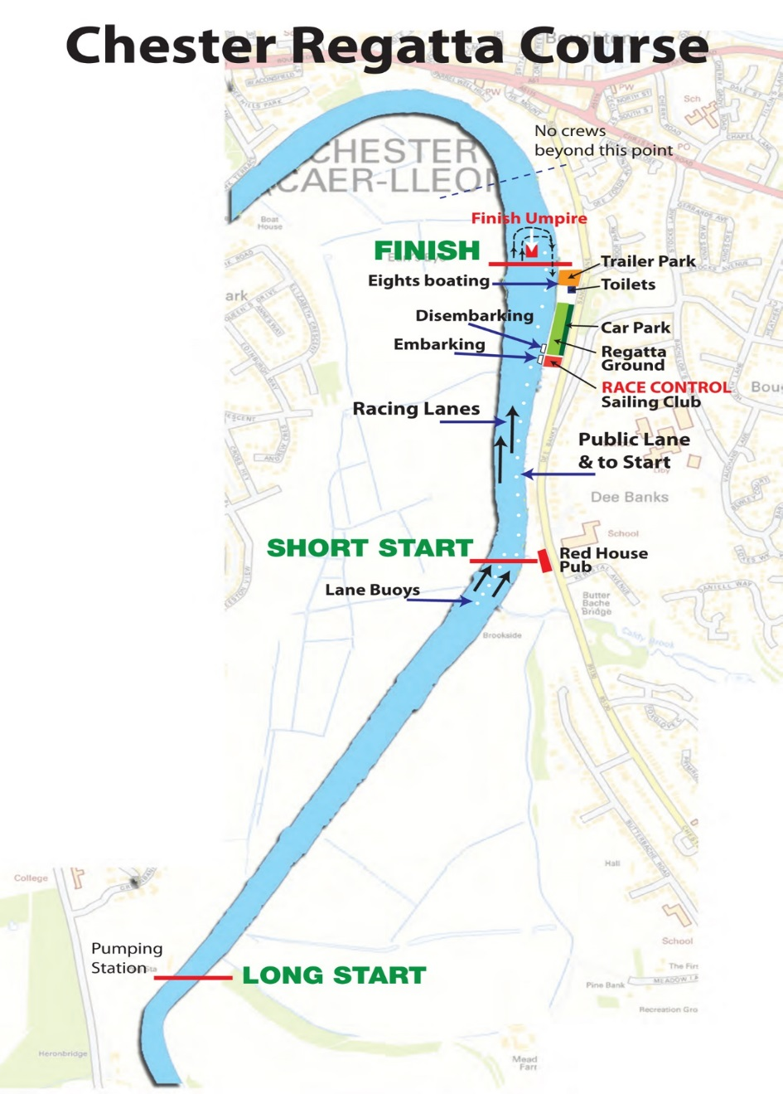
Figure 2
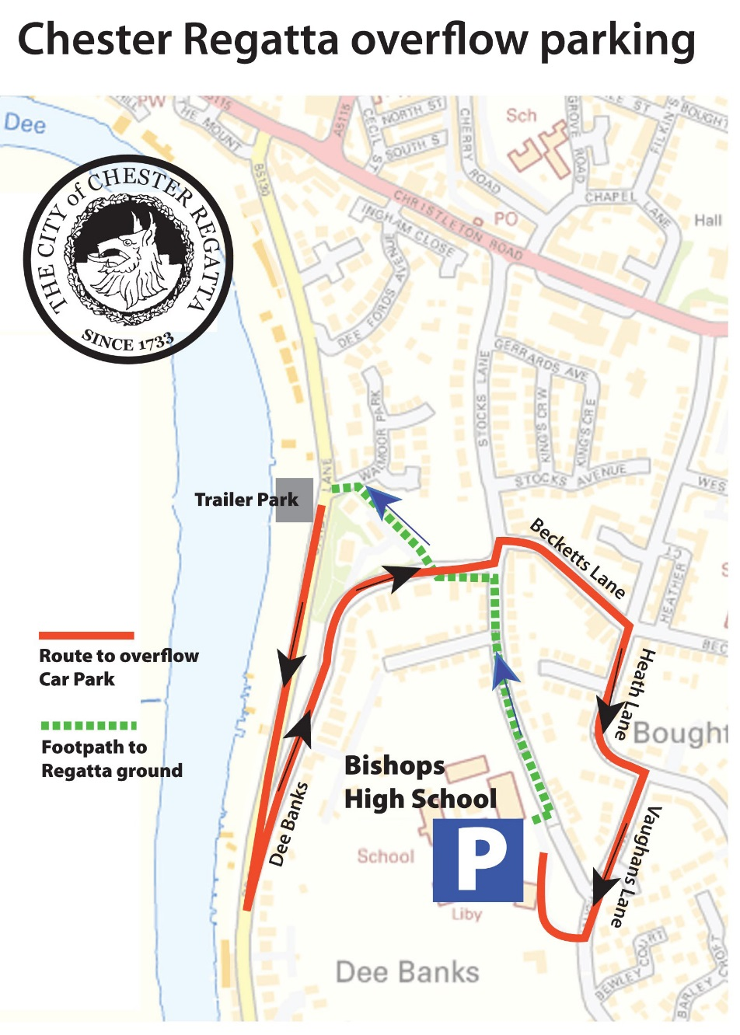

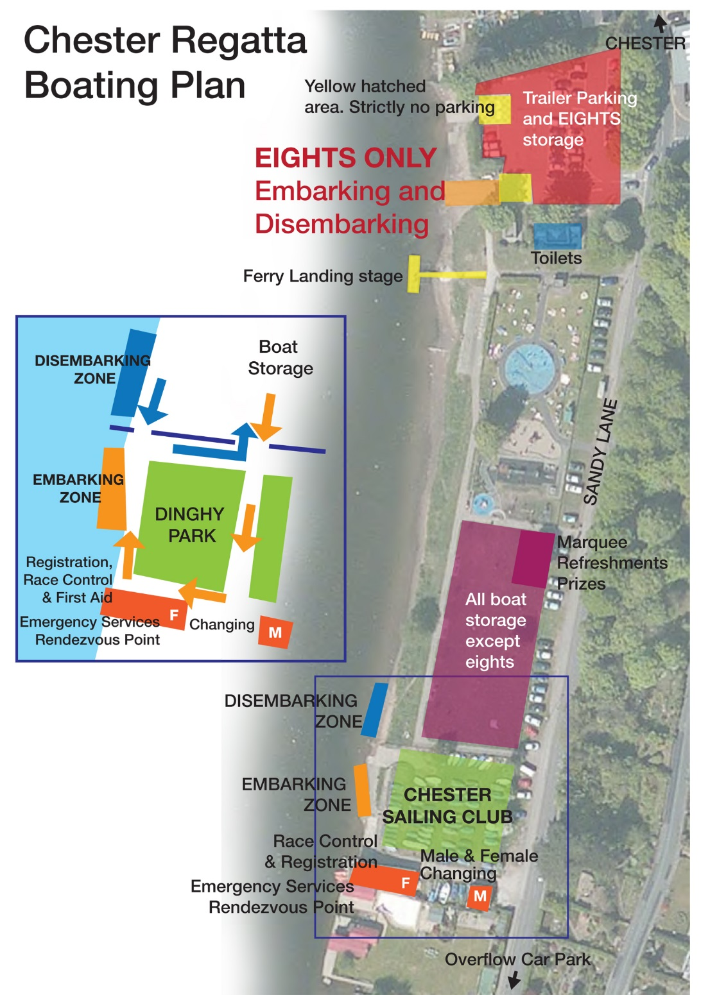
Figure 3

